**ASSETS FOR GAME DEVELOPERS**

**QUIZ#0.2**

|  |
| --- |
| **Table 1.1** |
| **Students’ names** |
|  |
|  |
|  |

BEFORE YOU BEGIN

* Form groups of up to 3 students.
* Write your names at table 1.1 above.
* Every group makes a **single** submission, aka only one member submits.
* Save this file to your computer as **Quiz0.2**.

Contents

Week 0.2: Activity 1 - Krita 2

Week 0.2: Activity 2 - GIMP 3

Week 0.1: Activity 3 – Texture Packer 4

Week 0.1: Activity 4 - Tiled 5

Week 0.1: Activity 5 - Blender 7

Week 0.1: Activity 6 - Audacity 9

Week 0.1: Activity 7 - Unity 10

The purpose of Activity Quiz0.2 is the installation of all the required software for the Assets for Game Developers course. The software packages are Krita, GIMP, Texture Packer, Tiled, Blender, Audacity and Unity.

# Week 0.2: Activity 1 - Krita

KRITA INSTALLATION

After the completion of this activity, you should have installed Krita. Krita is a free illustration and paining program.

Follow the steps below:

1. Open any web browser and type <https://krita.org/en/>.
2. Click on the Download link.
3. Click on the **Windows Installer 64-bits** button.

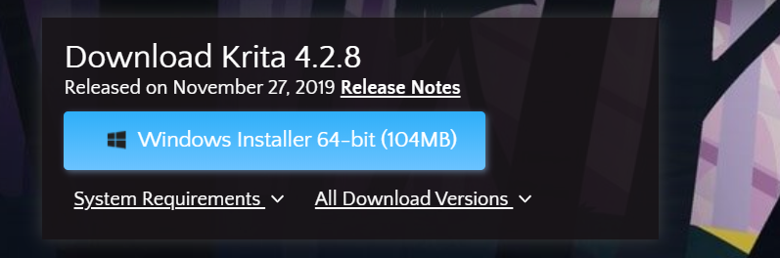

1. After the download is completed click on the executable file.
2. Click Yes.
3. At the Welcome Menu click Next.
4. At the License Agreement select the **“I accept the terms of the License Agreement”** option and click Next.
5. At the Installation Path menu pick an Installation Path and click Next.
6. At the Select Components menu click Next.
7. At the License Agreement menu select **I Agree**.
8. Then click Next.
9. At the next menu click Next.
10. At the final menu click **Install**.
11. Wait for the installation.
12. Click Next and then Finish.
13. Double-Click on the Shortcut on your Desktop.

|  |
| --- |
| Q1. Take a screenshot of the Krita Welcome Screen. |
|  |

Week 0.2: Activity 2 - GIMP  
GIMP INSTALLATION

The purposed of this task is the downloading and installation of GIMP. GIMP is a free image editor, for free-form editing, image convertion, color management and effects application.

Follow the steps below:

1. Open any web browser and type <https://www.gimp.org/downloads/>
2. Click on the **Download GIMP 2.10.14** (or any other version) **directly** link.

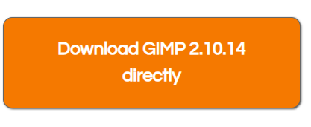

1. After the completion of the download, click on the executable file.
2. Select Yes.
3. At the language selection menu pick English and OK.
4. At the next menu click the **Customize** button.
5. Click Next.
6. At the Components menu select all the component (only the Translations is not necessary).
7. Click Next.
8. Select the **“Create a desktop icon”** option and click Next.
9. Then click Install.
10. Wait for the installation.
11. Click Finish.
12. Double-click on the GIMP Desktop icon.

|  |
| --- |
| Q2. Take a screenshot of the GIMP Welcome Screen. |
|  |

Week 0.1: Activity 3 – Texture Packer  
TEXTURE PACKER INSTALLATION

The purposed of this task is the downloading and installation of the Texture Packer. Texture Packer is a free Sprite-creation editor, which published the Sprites in formats compatible to various game engines and rendering programs.

Follow the steps below:

1. Open any web browser.
2. In the address bar type: <https://www.codeandweb.com/texturepacker/download>
3. Click on the Windows (64-bit) icon.
4. After the completion of the download, click on the executable file.
5. At the Welcome Screen click Next.
6. At the License Agreement select the **“I accept the terms of the License Agreement”** option and click Next.
7. At the Custom Setup Screen select an Installation Path and click Next.
8. At the final screen click Install.
9. Then click Yes.
10. After the completion of the Installation click Finish.
11. Click on the Texture Packer Desktop Icon.
12. Click Agree.
13. Click Agree again.
14. Click on the Use Free Version button.
15. At the Game Engine Selection select Unity.

|  |
| --- |
| Q3. Take a screenshot of the Texture Packer Welcome Screen. |
|  |

Week 0.1: Activity 4 - Tiled  
TILED INSTALLATION

The purposed of this task is the downloading and installation of the Tiled Utility. Tiled is Map Editor a free editor for developing tile maps and designing level’s content.

Follow the steps below:

1. Open any web browser.
2. In the address bar type: <https://www.mapeditor.org/download.html>
3. Click on the Download Now Icon.

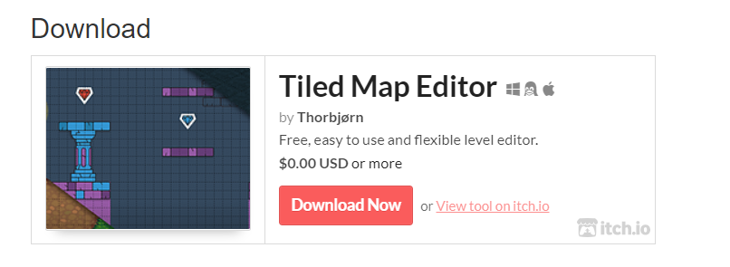

1. Click on the No thanks, just take me to the downloads.

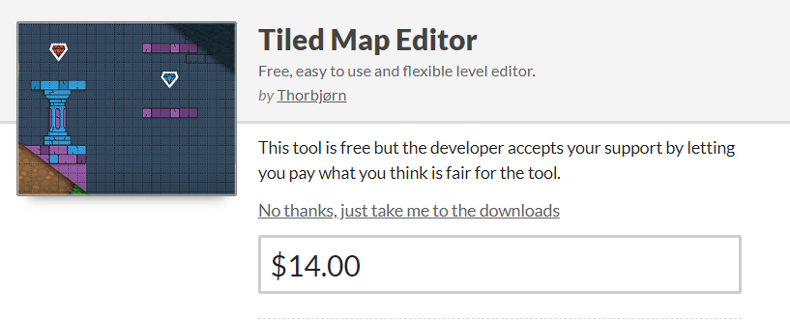

1. Click on the Download icon next to the Tiled Installer for Windows.
2. After the completion of the download, click on the executable file.
3. If asked select **More Info** and then **Run Anyway**.
4. At the Welcome Screen click Next.
5. At the License Screen, select the “**I accept the terms in the License Agreement”** and click Next.
6. At the Installation Path Menu select a Path and Click Next.
7. Then click Install.
8. Then Yes.
9. In the end of the Installation click Finish.
10. The Tiled should be launched automatically (if not double-click on the Tiled Desktop Icon).

|  |
| --- |
| Q4. Take a screenshot of the Tiled Welcome Screen. |
|  |

Week 0.1: Activity 5 - Blender  
BLENDER INSTALLATION

The purposed of this task is the downloading and installation of Blender. Blender is a free rendering, modelling, rigging and animation software, suitable for game and animation creation.

Follow the steps below:

1. Open any web browser.
2. In the address bar type: <https://www.blender.org/download/>

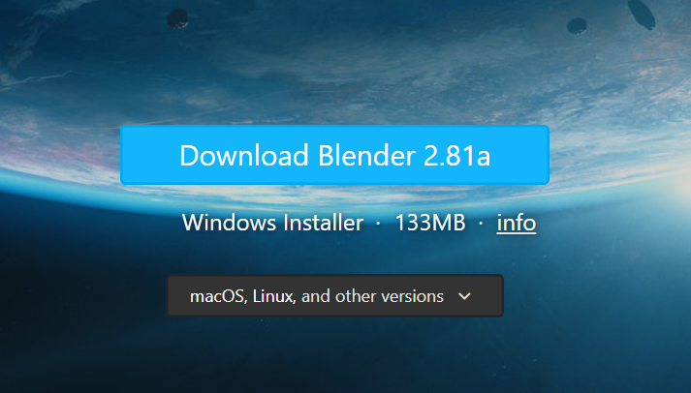

1. After the completion of the download, click on the executable file.
2. At the License Screen, select the “**I accept the terms in the License Agreement”** and click Next.
3. At the Installation Path screen, select an installation path and click Next.
4. At the next screen click Install.
5. After the completion of the installation click Finish.
6. Double-click on the Blender Desktop Icon.

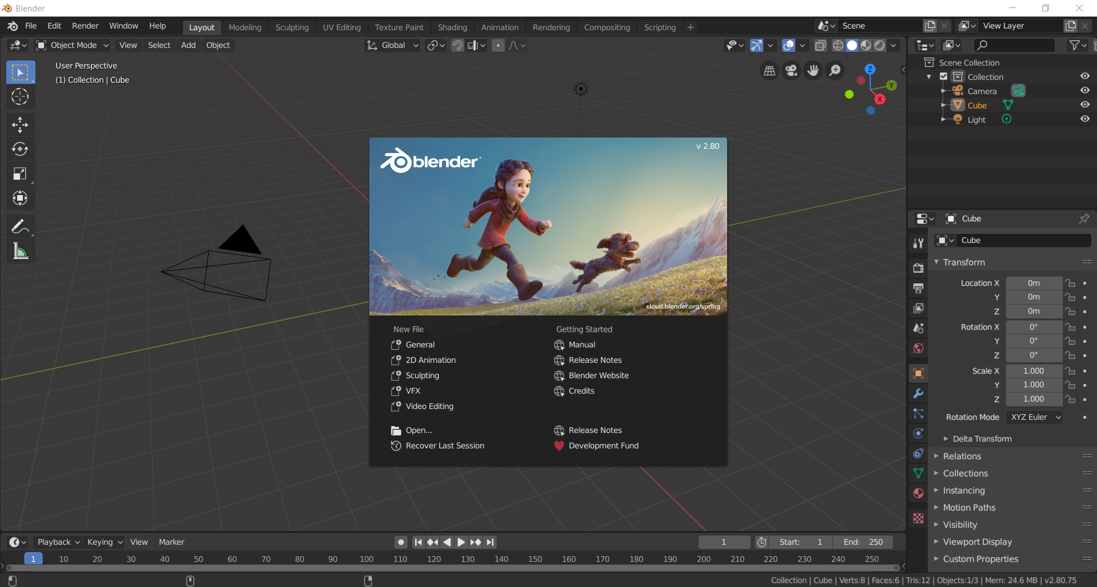

|  |
| --- |
| Q5. Take a screenshot of the Blender Welcome Screen. |
|  |

Week 0.1: Activity 6 - Audacity  
AUDACITY INSTALLATION

The purposed of this task is the downloading and installation of Audacity. Audacity is a free multi-track audio editor and recorder.

Follow the steps below:

1. Open any web browser.
2. In the address bar type: <https://www.audacityteam.org/download/>
3. Click on the Audacity for Windows icon.
4. Click on the Audacity 2.3.3 installer (or any other version). 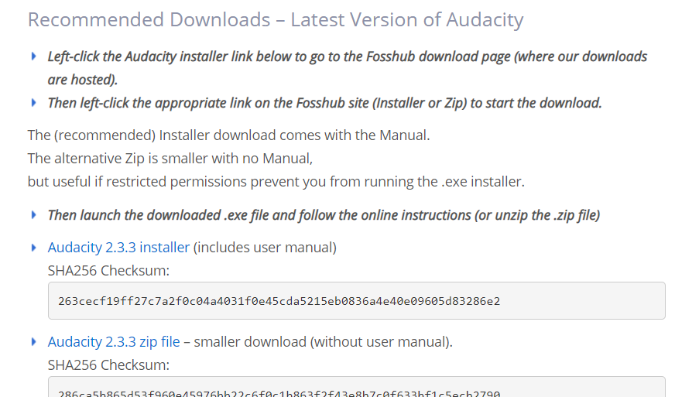
5. Click on the Audacity Windows Installer link.
6. After the completion of the download, click on the executable file.
7. At the Language selection screen select English and click OK.
8. At the Welcome Screen, click Next.
9. At the License Agreement screen select Next.
10. At the Custom Setup screen select an Installation path and click Next.
11. Select the Create a Desktop Icon option and click Next.
12. Then click Install.
13. After the completion of the Installation click Next.
14. At the last screen click Finish.
15. The Audacity should start automatically.

|  |
| --- |
| Q6. Take a screenshot of the Audacity Welcome Screen. |
|  |

Week 0.1: Activity 7 - Unity  
UNITY GAME ENGINE INSTALLATION

The purposed of this task is the downloading and installation of the Unity Game Engine. Unity is a Game Engine for the design and development of computer or mobile games.

BEFORE YOU BEGIN

* Check for previous Unity versions.
* You should also need to install the Visual Studio 2017 Community edition, with at least some of its workloads.

Part 1: Unity

Follow the steps below:

1. Visit the webpage: <https://unity3d.com/get-unity/download>
2. Click on the **Unity Hub** button.
3. Click on the downloaded .exe file.
4. Select Yes.
5. Click Agree.
6. Select an installation path and click Install.
7. When the installation is completed press Finish.
8. If asked: Allow the access to all your networks clicking **Allow**.
9. Click on the Download button.
10. Click on the Download button next to the latest Unity version.
11. In the popup windows Agree.
12. Click Yes.
13. After the installation is completed close the Unity Hub.

Part 2: Visual Studio

After the completion of this activity the Visual Studio will be installed in the students’ computers.

Follow the steps below:

1. Visit the Visual Studio webpage: <https://visualstudio.microsoft.com/downloads/> .
2. Under the **Downloads**, find the **Community** version and click on the **Free download** button.

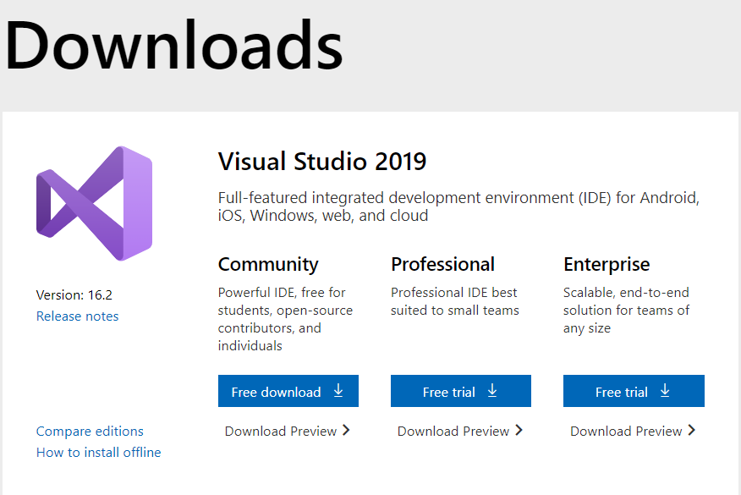

1. Click on the downloaded .exe file (top right or bottom left corner of your browser).
2. At the first Installer screen click Continue.
3. Wait for the files’ downloading and installation.
4. In the next screen, click **Install** under the Visual Studio Community version.
5. In the next screen, select at least the **Universal Windows Platform development** and the **Game Development with Unity** option (select the box).

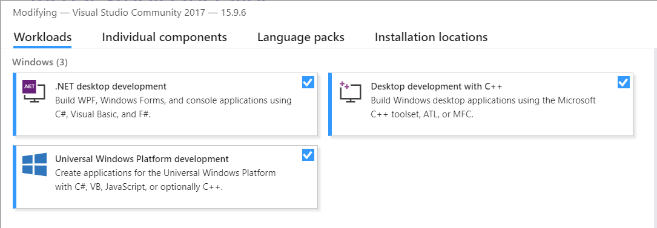

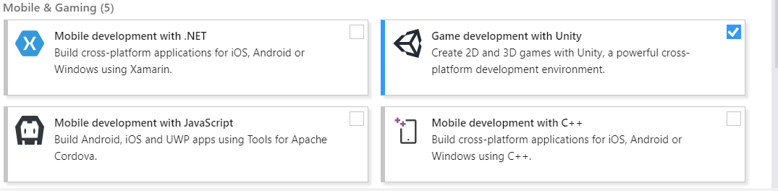

|  |
| --- |
| Q7. Take a screenshot of the Unity Welcome Screen. |
|  |

|  |
| --- |
| Q8. Take a screenshot of the Visual Studio Welcome Screen. |
|  |

Once you have submitted the assignment, your instructor will be able to view your submission and will grade the submission in the near future. Today’s assignment won’t get any marks.